1.Install Kubernetes

curl -s <https://packages.cloud.google.com/apt/doc/apt-key.gpg>| apt-key add - echo "deb <http://apt.kubernetes.io/>kubernetes-xenial main"

>/etc/apt/sources.list.d/kubernetes.list apt-get update apt-get install -y kubelet kubeadm kubectl

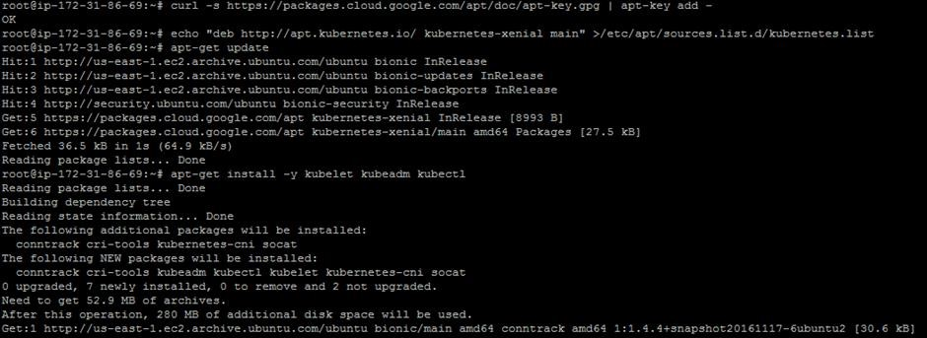

kubeadm init

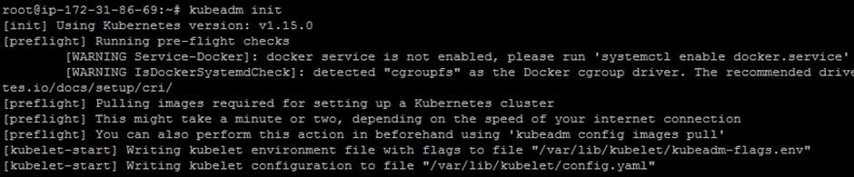

mkdir -p $HOME/.kube

sudo cp -i /etc/kubernetes/admin.conf $HOME/.kube/config

sudo chown $(id -u):$(id -g) $HOME/.kube/config

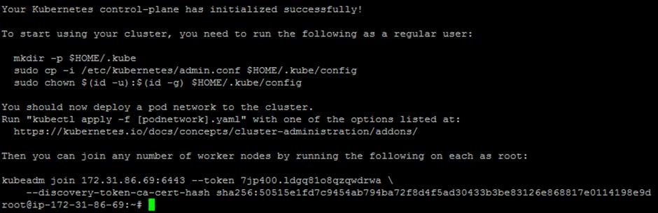

export kubever=$(kubectl version | base64 | tr -d '\n') kubectl apply -f "[https://cloud.weave.works/k8s/net?k8s-version=$kubever"](https://cloud.weave.works/k8s/net?k8s-version=$kubever)

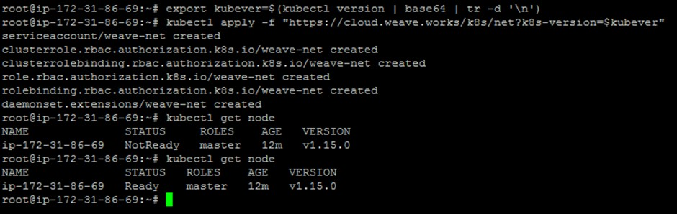

kubectl get node

kubectl get pods --all-namespaces

